Project Design Phase-II Technology Stack (Architecture & Stack)

|  |  |
| --- | --- |
| Date | 19 October 2022 |
| Team ID | PNT2022TMID23663 |
| Project Name | Signs with Smart Connectivity for Better Road Safety |
| Maximum Marks | 4 Marks |

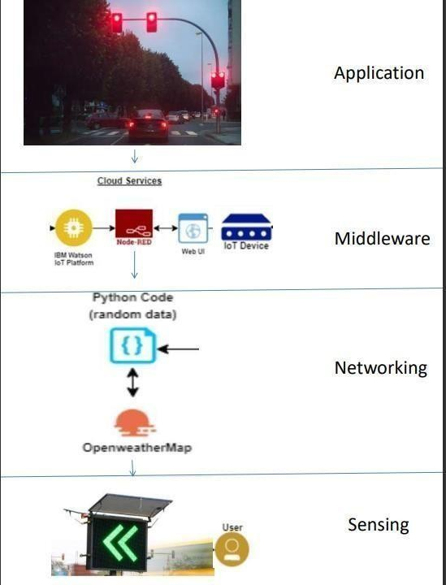

|  |  |  |  |  |
| --- | --- | --- | --- | --- |
| **GUIDELINES:**   * To replace the static signboards, smart connected sign boardsare used. * These smart connected sign boards get the speed limitationsfrom a web app using weather API and update automatically. * Based on the weather changes the speed may increaseor decrease. * Based on the traffic and fatal situations the diversion signsare displayed. * Guide(Schools), Warning and Service(Hospitals, Restaurant) signs are also displayed accordingly. * If there is rainfall then the roads will be slippery and the speed limit would be decreased. * There is a web app through which you can enter the data of the road diversions, accident prone areas and the information sign boards can be entered through web app.   This data is retrieved and displayed on the sign boards accordingly.   * Different modes of operations can be selected with the helpof buttons. | | | | |
| **S.No** | **Component** | **Description** | **Technology** |  |
| 1. | User Interface | How user interacts with application eg. Web UI, Mobile App, Chatbot etc. | HTML, CSS, JavaScript  / Angular Js / React Js etc. |
| 2. | Application Logic-2 | Logic for a process in the application | IBM Watson STT service |
| 3. | Application Logic-3 | Logic for a process in the application | IBM Watson Assistant |
| 4. | Cloud Database | Database Service on Cloud | IBM DB2, IBM Cloudant etc. |
| 5. | External API-1 | Purpose of External API used in the application | IBM Weather API, etc. |
|  | | | | |

|  |  |  |  |  |
| --- | --- | --- | --- | --- |
| **Table-2: Application Characteristics** | | | | |
| **S.No** | **Characteristics** | **Description** | **Technology** |  |
| 1. | Security Implementations | Strong security system that anyone without login credentials and hackers are not allowed to enter  the network. | Firewall, Firebase, cyber resiliency strategy |
| 2. | Scalable Architecture | Easy to expand the operating range by  increasing the bandwidth of the network. | IoT, internet. |
| 3. | Availability | Available anytime and everywhere 24/7 as long as the user is signed into the network. | IBM Cloud |
| 4. | Performance | Supports a large number of users to  access the technology simultaneously. | IBM cloud |
|  | | | | |